PARTS LIST:
1 | Fortis Bull Nose Front Bumper | 4 | 12mm Lock Washers
1 | Driver/Left Frame Mounting Bracket | 4 | 12mm Hex Nuts
1 | Passenger/Right Frame Mounting Bracket | 4 | 8mm x 25mm Hex Bolts
1 | Driver/Left Support Bracket | 2 | 8mm x 16mm Hex Bolts
1 | Passenger/Right Support Bracket | 10 | 8mm x 24mm OD x 2mm Flat Washers
1 | Driver/Left L-Bracket | 6 | 8mm Lock Washers
1 | Passenger/Right L-Bracket | 4 | 8mm Hex Nuts
2 | License Plate Plugs | 7 | 6mm x 25mm Button Head Bolts
1 | ACC Relocation Bracket | 10 | 6mm x 18mm OD x 1.6mm Flat Washers
1 | ACC Late Style Bracket | 7 | 6mm Lock Washers
1 | ACC Plastic Cover | 7 | 6mm Hex Nuts
4 | 12mm x 45mm Hex Bolts | 1 | 4mm Hex Wrench
8 | 12mm x 37mm OD x 3mm Flat Washers
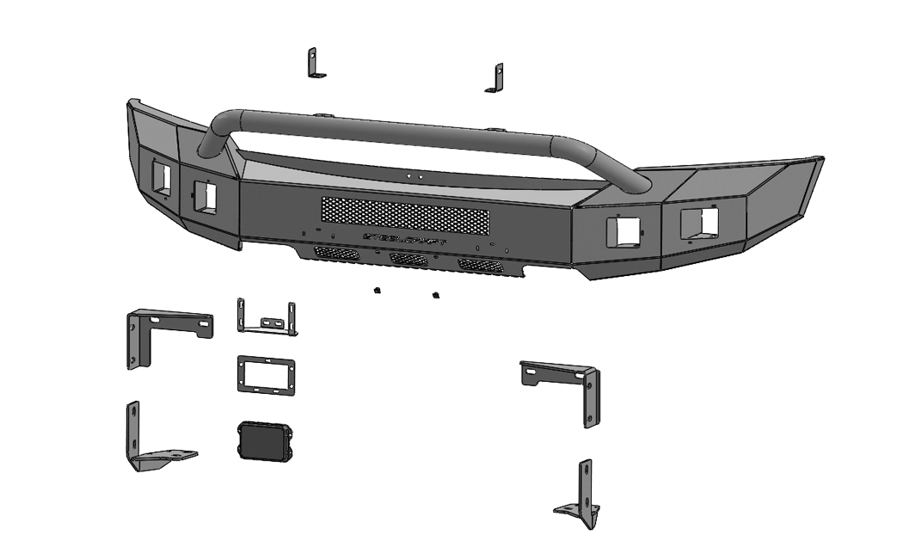

Passenger/Right Mounting Bracket

(2) License Plate Plugs
ACC Relocation Bracket

ACC Sensor Bracket
Driver/Left Mounting Bracket

ACC Plastic Cover

Driver/Left Support Bracket
Passenger/Right Support Bracket

PROCEDURE:
REMOVE CONTENTS FROM BOX. VERIFY ALL PARTS ARE PRESENT. READ INSTRUCTIONS CAREFULLY BEFORE STARTING INSTALLATION. BUMPER IS HEAVY, ASSISTANCE IS HIGHLY RECOMMENDED TO AVOID POSSIBLE INJURY OR DAMAGE TO THE VEHICLE. BUMPER INSTALLATION WILL INTERFERE WITH GRILLE MOUNTED CAMERA.
- Remove the license plate and bracket. Release the wiring harness from the clips attached to the back of the bumper. Move all wiring harnesses away from bumper.
- Next, remove the plastic bumper pads, (Figure 1). NOTE: Release metal clips from back of bumper to remove bumper pad assembly. It may be easier to access bumper hardware with plastic air dam removed from bottom of bumper.
- Place blocks or jack stands under the front bumper to support it during mounting bolt removal. Once the bumper has been safely supported, remove the large hex nut from the back of each bumper bracket, (Figure 2). Next, from the front of the bumper, remove the (2) factory hex nuts attaching the bumper to each bumper bracket, (Figure 3). WARNING! Assistance is required to hold the bumper in place during bolt removal to prevent the bumper from falling. Carefully slide the bumper off over the tow hooks.
- Remove the tow hooks and plastic covers, (if equipped), from the bottom of the frame, (Figure 4).
- Next, select the Passenger/Right Support Bracket, (Figure 5). Reuse the factory hardware to attach the Support Bracket and factory tow hooks to the bottom of the frame.
- Select the Passenger/Right Mounting Bracket, (Figure 6). Reuse the factory hex nuts to attach the Mounting Bracket to the frame, (Figure 6). NOTE: The Mounting Bracket should be on the outside of the Support Bracket.
- Repeat Steps 5 and 6 to attach the Driver/Left Mounting Bracket, Support Bracket, and tow hook.
- If lights are to be installed, (Lights not included):
  - Attach lights to the square holes on each side of the Bumper, (Figure 7).
  - Follow Light manufacturer’s instructions to install the lights.
- Determine if vehicle is equipped with an adaptive cruise control, (ACC), and note the design of sensor. NOTE: Install the ACC assembly before attaching Bumper to vehicle.
Vehicles with early style ACC with tabs on ends:
- Select the ACC Plastic Cover and the Relocation Bracket, (Figure 8). Insert (3) 6mm Button Head Bolts through the Plastic Cover, the Relocation Bracket and out through the ACC sensor. Secure with (3) 6mm Flat Washers, (3) 6mm Lock Washers and (3) 6mm Hex Nuts.
- Next, attach the ACC assembly to the back of the bumper with (2) 8mm Hex Bolts, (4) 8mm Flat Washers and (2) 8mm Nylon Lock Nuts, (Figure 11).
Vehicles with late style ACC with tabs on top and bottom:
- Select the ACC Sensor Bracket, (Figure 9).
- Attach the ACC sensor to the back of the Bracket with the included (3) 6mm Button Head Bolts, (6) 6mm Flat Washers, (3) 6mm Lock Washers and (3) 6mm Hex Nuts,
- Attach the ACC and Sensor Bracket to the back of the Relocation Bracket. Line up the plastic cover with the front of the Relocation Bracket. Insert (4) 6mm x 25mm Button Head Bolts through the ACC Plastic Cover, the Relocation Bracket, the Sensor Bracket, (Figure 10). Secure with (4) 6mm Flat Washers, (4) 6mm Lock Washers and (4) 6mm Hex Nuts.
- Next, attach the ACC assembly to the back of the bumper with (2) 8mm Hex Bolts, (4) 8mm Flat Washers and (2) 8mm Nylon Lock Nuts, (Figure 11).
- With assistance, position the Bumper Assembly onto the outside of the Mounting Brackets. Temporarily support the weight of the Bumper. WARNING: To avoid possible injury or damage to the vehicle, do not proceed until the bumper is fully and safely supported.
- Attach the Bumper to the Brackets with (4) 12mm Hex Bolts, (8) 12mm Flat Washers, (4) 12mm Lock Washers and (4) 12mm Hex Nuts, (Figure 12). Do not tighten.
- Level and adjust the bumper and fully tighten all 12mm hardware to 65-70ft-lbs. NOTE: If additional in-out adjustment is required, loosen Bracket Hardware, slide the Bracket in or out as necessary and fully tighten all hardware.
- Reattach the wiring harness. Adjust lights as necessary and tighten all fog light bracket hardware.
- Use the included (2) push-in plastic nuts to attach the front license plate, (if required), to the (2) holes in the front bumper, (Figure 13).
- Do periodic inspections to the installation to make sure that all hardware is secure and tight.

To protect your investment, Do not use any type of polish or wax that may contain abrasives that could damage the finish. Mild soap may be used to clean the Full Replacement Front Bumper assembly.

Passenger/right Side Installation Pictured

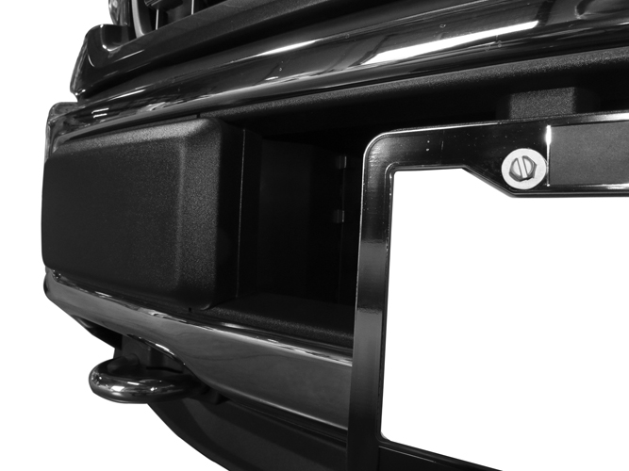
(Fig 1) From behind bumper, release metal clips attaching plastic bumper pad to the bumper
Front

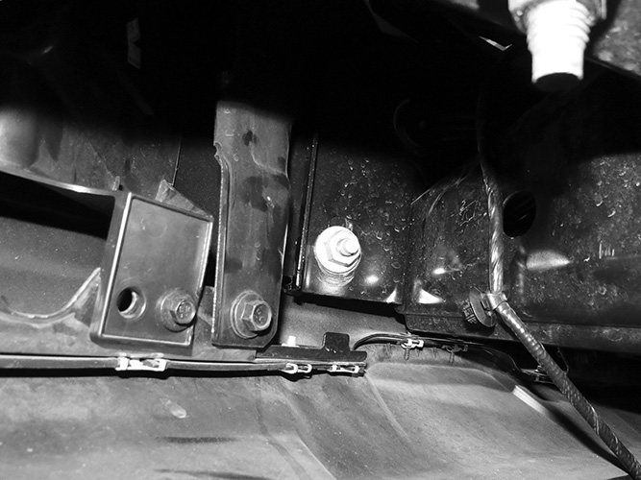

Front
(Fig 2) Remove factory hex nut (arrow) from back of bumper bracket (Driver side pictured)

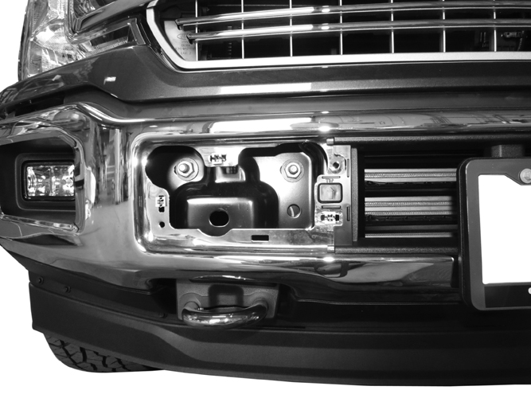
(Fig 3) Remove (2) factory hex nuts from each side

WARNING! Do not remove bumper bolts unless the bumper is properly supported on blocks or stands or the bumper may fall.

Passenger/right Side Installation Pictured
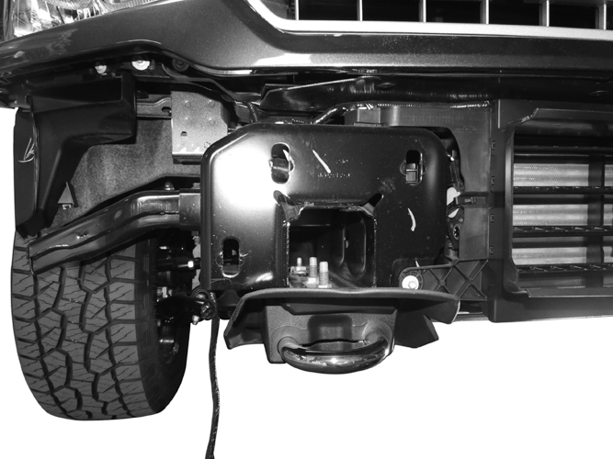

(Fig 4) Remove the tow hooks and plastic covers, if equipped

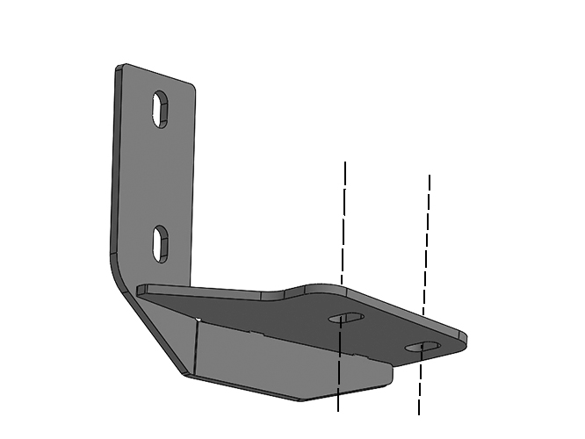

Front
(Fig 5) Reuse the factory hardware to attach the Passenger/Right Support Bracket

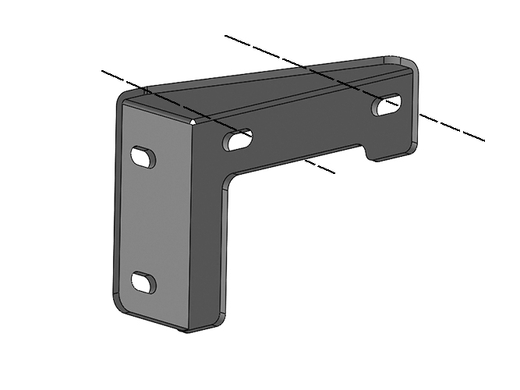

(Fig 6) Reuse the factory hardware to attach the Passenger/Right Mounting Bracket to the frame
Front

Passenger/right Side Installation Pictured
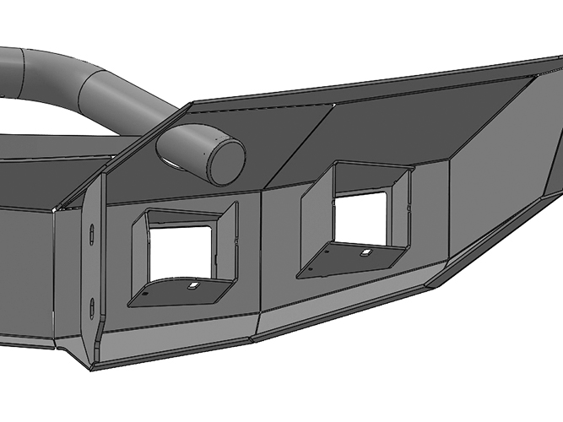
Front

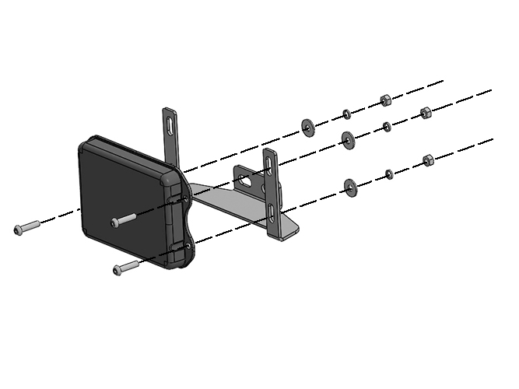
(Fig 8) Attach Plastic Cover and “early style” Adaptive Cruise Control sensor to the Relocation Bracket
(3) 6mm Button Head Bolts
(3) 6mm Flat Washers
(3) 6mm Lock Washers
(3) 6mm Hex Nuts
Front

(Fig 7) Optional Attach lights to the sides of the Bumper, (Lights not included)

(3) 6mm Button Head Bolts
(3) 6mm Flat Washers
(3) 6mm Lock Washers
(3) 6mm Hex Nuts

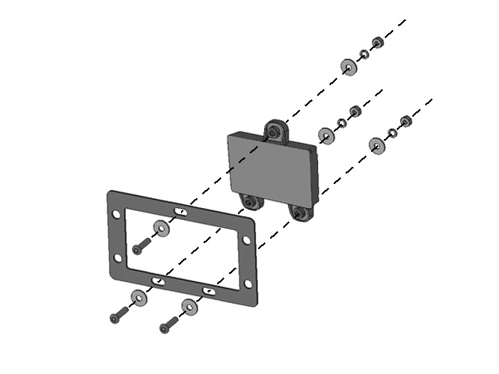

Front

(Fig 9) Attach the “late style” ACC sensor to back of Adapter Plate

Passenger/right Side Installation Pictured
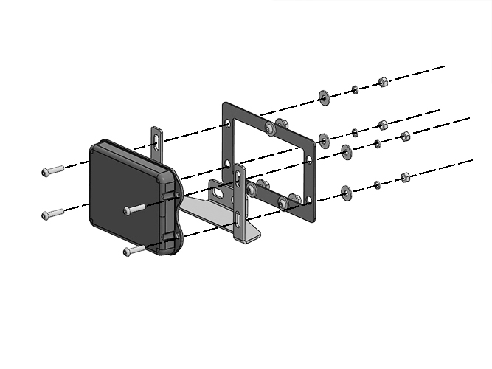
Front
(Fig 10) Attach the Plastic Cover and “late style” ACC assembly to the U-Bracket
(4) 6mm Button Head Bolts
(4) 6mm Flat Washers
(4) 6mm Lock Washers
(4) 6mm Hex Nuts

(2) 8mm Hex Bolts
(4) 8mm Flat Washers
(2) 8mm Lock Washers
(2) 8mm Hex Nuts

(Fig 11) Attach ACC assembly to the Bumper

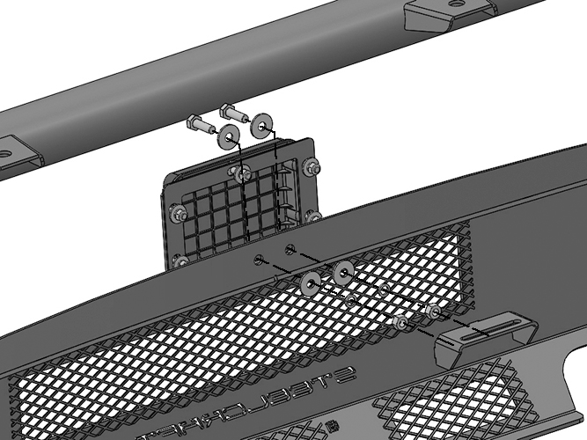

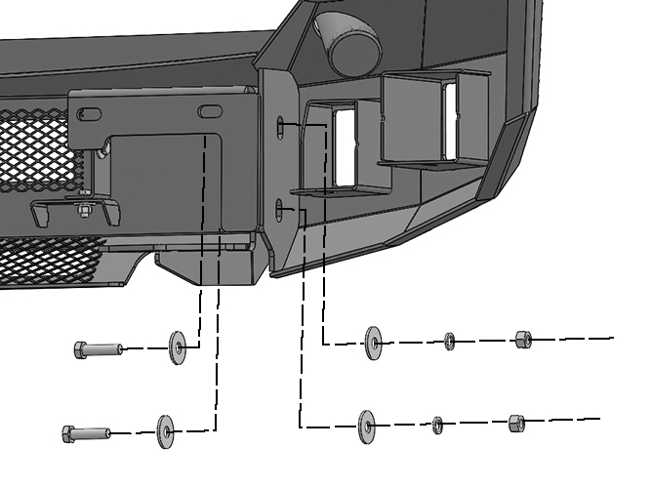
(Fig 12) Attach Bumper to Brackets
Front

(2) 12mm Hex Bolts
(4) 12mm Flat Washers
(2) 12mm Lock Washers
(2) 12mm Hex Nuts

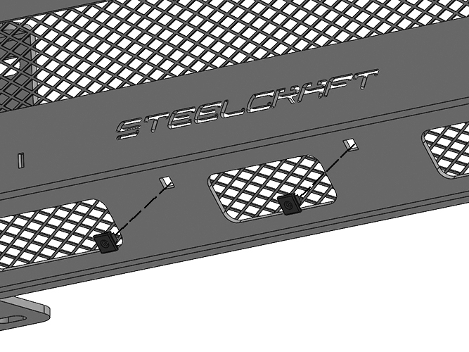

WARNING! Do not crawl under bumper unless the bumper is properly supported on blocks or stands or the bumper may fall.

(Fig 13) Push plastic plugs into holes in Bumper for license plate if required

