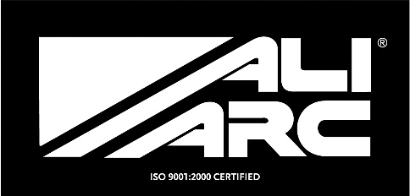
INSTALLATION INSTRUCTIONS
Applicable Models
GMB194 GMC 2500 - 2015 up
GMR194 GMC 2500 - 2015 up with Rake

Steps
Remove original bumper and support brackets
Separate Ali Arc steel mounts from Ali Arc bumper
Fasten Ali Arc steel mounts to frame using 4 original bolts holding support brackets
Fasten Ali Arc bumper to Ali Arc steel mounts using supplied bolt kits (4 - 50mm X 12mm)
Ensure Ali Arc bumper is sitting level and evenly spaced before completely tightening bolts.

Cleaning and Maintenance
Use soap and water. Avoid acid washes, as it will etch aluminum surface.
Original shine can be maintained by periodically using a standard metal polish.
We use and recommend Autosol.

