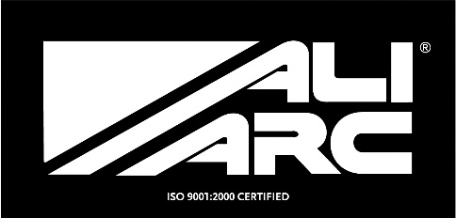
INSTALLATION INSTRUCTIONS
Applicable Models
CHB190 Chevy "NEW" Silverado LT1500 2007 - UP
CHR190 Chevy "NEW" Silverado LT1500 2007 - UP W/Rake

Steps
Remove original bumper (Remove outer bumper brackets and 2 through frame bolts)
Remove tow hook bolts from outside of frame (2 on passenger side, 1 on driver side)
Install Ali Arc bumper to outside of frame and fasten using original bolts.
There will be 4 bolts on the passenger side and 3 bolts on the driver side
Align the Ali Arc bumper before securely tightening bolts.

Cleaning and Maintenance
Use soap and water. Avoid acid washes, as it will etch aluminum surfaces.
Original shine can be maintained by periodically using a standard metal polish.
We use and recommend Autosol.

