INSTALLATION INSTRUCTIONS
Applicable Models
CHB193 Chevy Silverado 1500 2014 - UP
CHR193 Chevy Silverado 1500 2014 - UP W/Rake
CHB193H Chevy Silverado 1500 2014 - UP HD bumper
Steps
Remove original bumper, tow hooks and bumper mounting bracket from front of frame.
Install tow hooks extension brackets fasten using supplied 6 - 12 x 30 mm bolts. (Picture 1&2) Reinstall tow hooks using original bolts and supplied spacers.
Install Ali Arc bumper mounting brackets (mounting plates offset to outside) using 6 original bolts.
Install Ali Arc bumper, mounts are inside brackets, fasten using supplied 4 - 12 x 50 mm bolts. (Picture 3)
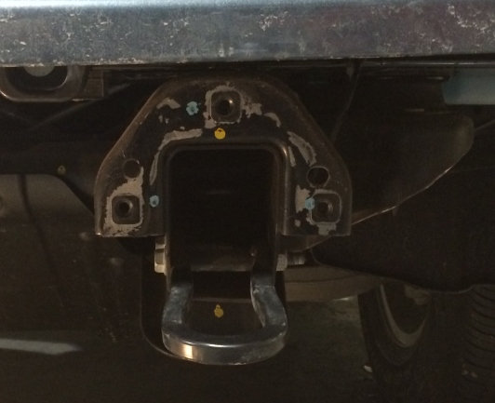
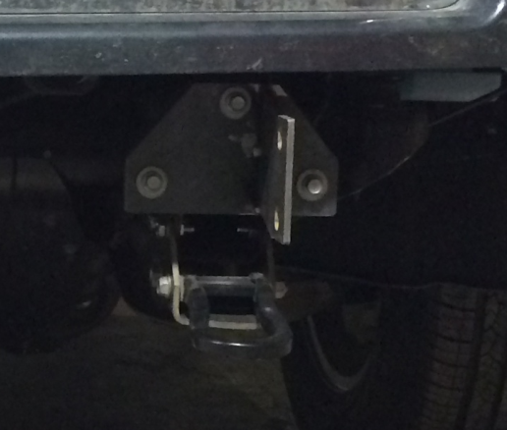
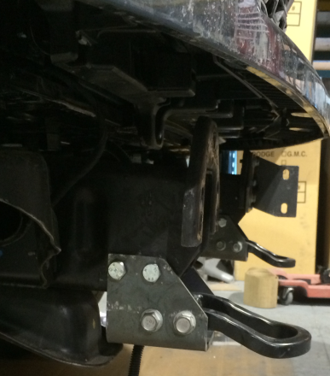
Align the Ali Arc bumper before securely tightening all bolts.
Picture 1 Picture 2 Picture 3
Cleaning and Maintenance
Use soap and water. Avoid acid washes, as it will etch aluminum surfaces.
Original shine can be maintained by periodically using a standard metal polish.

