We use and recommend Autosol.
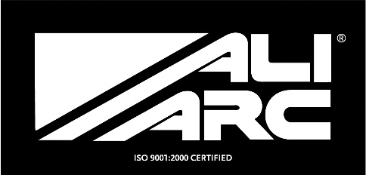
INSTALLATION INSTRUCTIONS
Applicable Models
CHR194 Chevy 2500 - 2015 up with Rake

Steps
Remove original bumper and support brackets
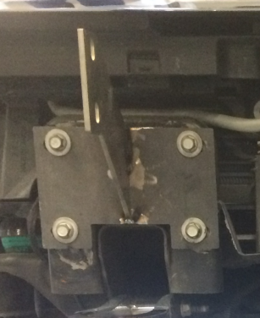
Separate Ali Arc steel mounts from Ali Arc bumper
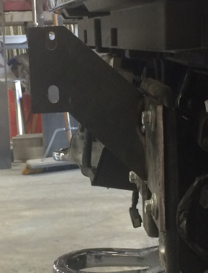
Fasten Ali Arc steel mounts to frame using 4 original bolts holding support brackets
Fasten Ali Arc bumper to Ali Arc steel mounts using supplied bolt kits (4 - 50mm X 12mm)
Ensure Ali Arc bumper is sitting level and evenly spaced before completely tightening bolts.

Cleaning and Maintenance
Use soap and water. Avoid acid washes, as it will etch aluminum surface.
Original shine can be maintained by periodically using a standard metal polish.
We use and recommend Autosol.

