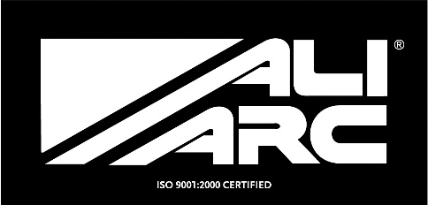
INSTALLATION INSTRUCTIONS
Applicable Models
GMB191 GMC 2500 2007 - UP
GMR191 GMC 2500 2007 - UP W/Rake
GMB191H GMC 2500 2007 - UP - HD bumper

Steps
Remove original bumper (Remove 2 through frame U-bolts)
Install Ali Arc bumper to outside of frame and fasten using original bolts.
Align the Ali Arc bumper before securely tightening bolts.

Cleaning and Maintenance
Use soap and water. Avoid acid washes, as it will etch aluminum surfaces.
Original shine can be maintained by periodically using a standard metal polish.
We use and recommend Autosol.

